**Airport Management System**

* + - * Team:
        1. Vinay Omkumar Khilwani (18BCP126)
        2. Vasu Gondaliya (18BCP123)
        3. Vaidehi Shah (18BCP121)
        4. Umang Mehta (18BCP120)

1. Introduction
   * + Airport
       - An airport is a place with extended facilities, mostly for commercial air transport. Airports often have facilities to store and maintain aircraft, and a control tower. An airport consists of a [landing area](https://en.wikipedia.org/wiki/Landing_area), which comprises an aerially accessible open space including at least one operationally active surface such as a [runway](https://en.wikipedia.org/wiki/Runway) for a [plane](https://en.wikipedia.org/wiki/Airplane) to take off or land and often includes adjacent utility buildings such as control towers, hangars, terminals, etc. Larger airports may have airport aprons, taxiway bridges, air traffic control centres, passenger facilities such as restaurants and lounges, and emergency services.
     + Airport Management
       - Increasing passenger growth coupled with capacity constraints means that operating an airport demands insight and collaboration for the timely allocation of workforces and assets as well as the ability to make the right, **efficient** and **correct** decisions at the right time to keep things moving, with the **correct**, **accurate**, **precise** information.
     + Database Management System
       - A Database Management System (DBMS) is a:
       1. Collection of interrelated data, **i.e.**, *Database.*
       2. Collective set of programs to access those data.
       3. An environment that is both convenient and efficient to use.
       - One single database, which is accessible to everyone, based on their type of accessibility.
     + File System
       - File System is supported by a conventional operating system. The system stores permanent records in *various* files, and it needs different application programs to extract the records from and add records to the appropriate files. Before database management systems (*DBMSs*) were introduced, organisations usually stored information in such systems.
       - Everyone maintains their own data, and updates (upload/delete) and extracts data on their system. The change may or may not get updated in other systems.



* + - Limitations of File System
      * Time Consuming
      * Error-prone Results
      * Less accuracy
      * Time inefficient
      * Uncertainty
    - Advantages of DBMS over the Existing System
      * Access from anywhere around the world
      * Access at any time
      * Better Communication
    - DBMS v/s. File System
    1. **Data Redundancy:**
       - * Data redundancy is the repetition of data. It is a common issue in computer data storage and database systems. In other words, it means that some data fields are repeated in the database. This repetition of data may occur either if the field is repeated within the same table, or if a field is repeated in two or more tables. It can also be simply defined as the presence of excessive data, along with the needful data.
         * Example: Let there be a relationship between two tables "Flight A" and "Flight B". The relation: "**B** is a connecting flight of **A**".

Flight A (Name, Passport_Number, Emergency_Contact, Seat_Number-1)

Flight B (Name, Passport_Number, Emergency_Contact, Seat_Number-2)

All the attributes are same in both the tables, except the "Seat Number". Hence, the data "Name, Passport Number, Emergency Contact" is repeated unnecessarily.

* + 1. **Data Inconsistency:**
       - * Data inconsistency is eventually a result of Data redundancy. In other words, the duplicate entries of the same data may no longer agree. That is, in simple terms, if a change is made to any data entry of a particular attribute (which is duplicated in two or more relations), then it is not sure that the same change will also occur in the other relations, where this attribute is duplicated.
         * Example: If a person self-checkin’s through his mobile phone beforehand, then that seat may not show up as "booked" in the database there at the "check-in" counter at the airport. This type of differing values in duplicate attributes lead to "Data Inconsistency" in "Airport Management System", when using "File Systems".
    2. **Difficulty in Accessing Data:**
       - * There are many different criterion on which the users want to access the data. Hence, it is very difficult in "File System" to access the data with any criteria. For every criteria, the data-processing team has to write different programs. Hence, it is very difficult and insufficient to access the data in "File System".
         * Example: Suppose if a manager of an airline, wants to get the details of the passengers, travelling in "Business Class" in a particular flight. Then, either he has to manually, note the passengers list, from the "passengers" table as a whole, or the other option is that the data-processing team writes a new program for it. This disadvantage isn’t faced when we use "DBMS".
    3. **Data Isolation:**
       - * Since data are scattered in various files, and files may be in different formats, writing new application programs to retrieve the appropriate data is difficult.
         * Example: Suppose, one airline has its data of flights in a ".xls" format and some other airline has its data in ".csv" format. Then, we will have to write two different application programs, separately for both the airlines, to access the data. Hence, it is insufficient to use "File System" over "DBMS".
    4. **Integrity Problems:**
       - * The data values stored in the database must satisfy certain types of "consistency constraints". Developers enforce these constraints in the system by adding appropriate code in the various application programs. However, when new and varying constraints are added, it is difficult to change the programs to enforce/follow them. The problem is more messed when constraints involve several data items from different files.
         * Example: Suppose the date of "travel" in the database, used by passengers is in the format "DD/MM/YY", but however, it has to be changed to "MM/DD/YY". So, for this change, the data team will face problems while enforcing this one-by-one in all the application programs.
    5. **Atomicity:**
       - * A computer system, like any other device, is subject to failure. In many applications, it is crucial that, if a failure occurs, the data be restored to the consistent state that existed before the failure. If a system failure occurs during the execution of the program, it is possible that it may result in an inconsistent database state. Clearly, it is essential to maintain database consistency. Also, the change/update must be *atomic -* it must happen entirety or not at all. Hence, it is difficult to ensure atomicity in a conventional file-processing system.
         * Example: Consider a program to book a ticket at the airline’s airport window. Suppose, at the payment page, the payment is done, and at the same time, the system crashes, before the passenger is allotted the seat(s). Hence, in case of the system crash, the change/update should happen entirely or should not happen at all. This is the main problem faced when we deal with "File Systems".
    6. **Concurrent Access:**
       - * Different users can access the same files, at the same time. For the sake of overall performance of the system and faster response, many systems allow multiple users to update the data simultaneously. But, in file system, when different users update the data in the same file, it may happen that the change of one gets overridden by the change, made by the other user.
         * Example: If two users try to self-checkin through their mobiles at the same time, for the same seat. It may happen that only the second user gets allotted that seat (actually), but "Seat Allocated" message is shown to both the passengers. This type of problem will eventually lead to data inconsistency and hence is a major drawback of "File System".
    7. **Security Problems:**
       - * Not every user of the database system should be able to access all the data. Since application programs are added to the file-processing system in an ad hoc manner, enabling the different security constraints for different users is difficult.
         * Example: If all the passengers have access to the "table/file" of all passengers on some flight, there will be some who will add some passengers to that list, who haven’t paid and booked the seat. Also, there may be some passengers who will delete the data of other passengers, in order to get the booking done for his neighbours, colleagues, friends, etc. without any cost at all. Hence, different users should be given different type of access to data, based on their designation and position, which is a messy task in "File System".
       - Due to these huge disadvantages of "File System", the evolvement of "*DBMS*" over "*File System*" has increased exponentially, to manage the tasks in a more proper and efficient manner.

1. Relational Model
   * + Relational Database
       - A relational database consists of a collection of tables, each of which is assigned a unique name.
       - Relation: Refers to a Table.
       - Tuple: Refers to a row of a Table.
       - Attribute: Refers to a column of a Table.
       - Domain of Attributes: The set of all allowed values for each attribute is called the *domain of the attribute*.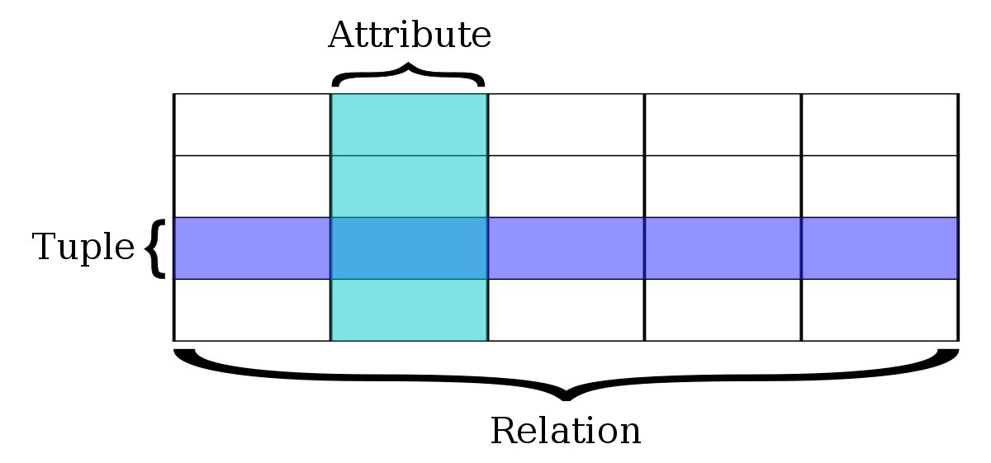
     + Schema-Instance Distinction
       - **Database Schema** is a logical design of the database.
       - **Database Instance** is a snapshot of the data in the database at a given instant of time.
       - Thus, database schema will not change with time while database instance can. The concept of a relation corresponds to the programming-language notion of a variable, while the concept of a relation schema corresponds to the programming-language notion of type definition. In general, a relation schema consists of a list of attributes and their corresponding domains. The concept of a relation instance corresponds to the programming - language notion of a value of a variable. The value of a given variable may change with time. Similarly, the contents of a relation instance may change with time as the relation is updated. In contrast, the schema of a relation does not generally change.
     + Database Schema of our Project
       - **AIRLINE** (Airline_ID, Name, 3_Digit_Code)
       - **AIRPORT** (Airport_ID, Name)
       - **CITY** (City_ID, Name, City, State)
       - **FLIGHT** (F_Code, Type, Source, Destination, D_Hr, A_Hr, A_Min, D_Min, D_Date, A_Date, AT_No, DT_No)
       - **EMPLOYEE** (Employee_ID, First_Name, Middle_Name, Last_Name, Address_Line_1, Address_Line_2, City, Country, Pin_Code, Salary, Mobile_No, DOB, Job_Type, Gender)
       - **STORES** (Store_ID, Name, Store_Type)
       - **PASSENGER** (Passenger_ID, First_Name, Middle_Name, Last_Name, Address_Line_1, Address_Line_2, City, Country, Pin_Code, Mobile_No, DOB, ID_Type, Gender)
       - **TICKET** (Ticket_Number, Price, Class, Booking_Date, Seat_No)
       - **CONTAINS** (Airport_ID, Airline_ID)
       - **AIRPORT_T** (Airport_ID, T_No, Type)
       - **C_HAS_AP** (City_ID, Airport_ID)
       - **AL_HAS_FL** (Airline_ID, F_Code)
       - **CARRIES** (F_Code, Passenger_ID)
       - **AP_HAS_EMP** (Airport_ID, Employee_ID)
       - **A_HAS_S** (Airport_ID, Store_ID)
       - **BOOKS** (Ticket_Number, Passenger_ID)
       - **CANCELS** (Cancellation_ID, Ticket_Number, Passenger_ID, Date, Charges)
     + Relational Diagram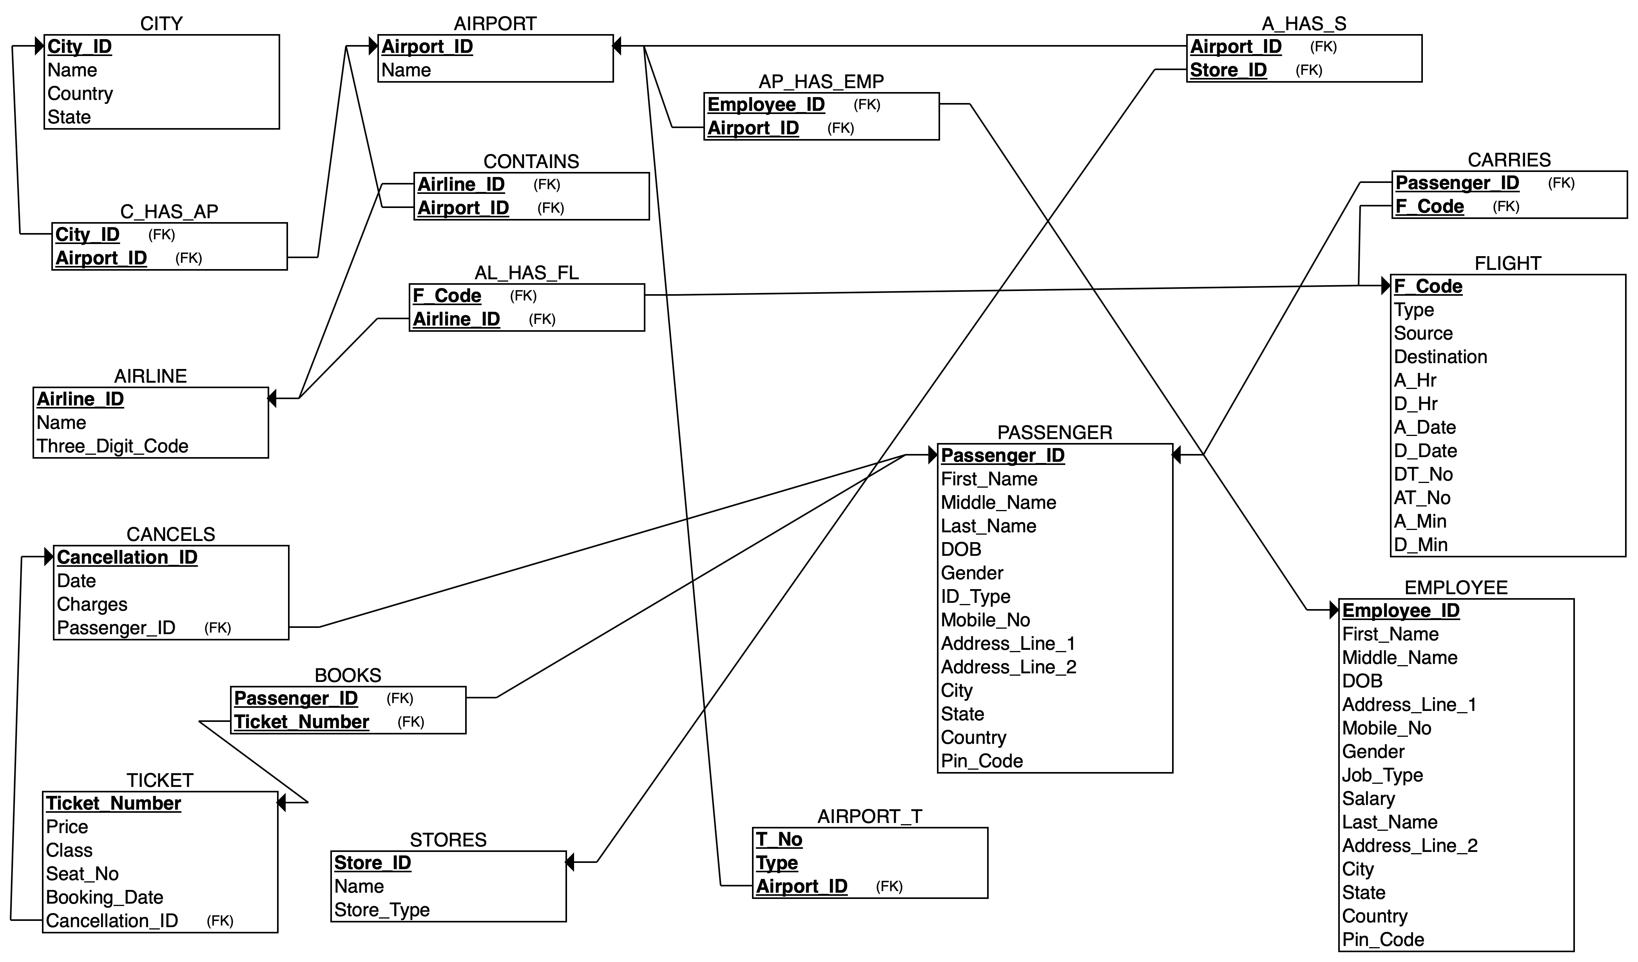
     + Keys
       - **Primary Key:** It is a special relational database table column (or combination of columns) designated to uniquely identify all table records. A primary key’s main features are:
         1. It must contain a unique value for each row of data.
         2. It cannot contain null values.
       - A primary key is either an existing table column or a column that is specifically generated by the database according to a defined sequence.
       - **Super Key:** A superkey is a set of one or more attributes that, taken collectively, allow us to identify uniquely a tuple in a relation.
       - **Candidate Key:** Superkeys for which no proper subset is a superkey, such minima superkeys are called candidate keys.
       - **Foreign Key:** A foreign key is a column or group of columns in a relational database table that provides a link between data in two tables. It acts as a cross-reference between tables because it references the primary key of another table, thereby establishing a link between them.
     + Foreign Keys in the Relations of our Project
       - **CONTAINS:** Airline_ID, Airport_ID
       - **C_HAS_AP:** Airport_ID, City_ID
       - **AIRPORT_T:** Airport_ID
       - **AL_HAS_FL:** Airline_ID, F_Code
       - **AP_HAS_EMP:** Airport_ID, Employee_ID
       - **A_HAS_S:** Airport_ID, Store_ID
       - **CARRIES:** Passenger_ID, F_Code
       - **CANCELS:** Ticket_Number, Passenger_ID
2. Entity-Relationship (ER) Model
   * + ER Model
       - The entity-relationship (E-R) data model was developed to facilitate database design by allowing specification of an enterprise schema that represents the overall logical structure of a database.
       - The E-R model is very useful in mapping the meanings and interactions of real-world enterprises onto a conceptual schema. Because of this usefulness, many database-design tools draw on concepts from the E-R model. The E-R data model employs three basic concepts: **entity sets, relationship sets**, and **attributes**. The E-R model also has an associated diagrammatic representation, the **E-R diagram**.
     + Entities and Entity Sets
       - An entity is a “thing” or “object” in the real world that is distinguishable from all other objects. An entity has a set of properties, and the values for some set of properties may uniquely identify an entity.
       - An entity is represented by a set of **attributes**, i.e., descriptive properties possessed by all members of an entity set.
       - An entity set is a set of entities of the same type that share the same properties, or attributes. A database thus includes a collection of entity sets, each of which contains any number of entities of the same type.
       - Weak Entity: Weak entity is an entity that depends on another entity. Weak entity does not have key attribute of their own. Double rectangle represents weak entity.
       - Attribute: An Attribute describes a property or characteristic of an entity. An attribute is represented using an eclipse.
       - Key Attribute: Key attribute represents the main characteristic of an Entity. It is used to represent Primary key. Ellipse with underlying lines represent Key Attribute.
       - Composite Attribute: An attribute can also have their own attributes. These attributes are known as Composite attribute.
     + Relationships and Relationship Sets
       - A relationship is an association among several entities.
       - A relationship set is a set of relationships of the same type. Formally, it is a mathematical relation on n ≥ 2 (possibly non-distinct) entity sets. If E1, E2,..., En are entity sets, then a relationship set R is a subset of **{(e1,e2,...,en) | e1 ∈ E1,e2 ∈ E2,...,en ∈ En}**, where **(e1,e2,...,en)** is a relationship. There are three types of relationship that exist between entities:
         1. Binary Relationship: Binary Relationship means relation between two Entities. This is further divided into four types:

One to One

One to Many

Many to One

Many to Many

* + - * 1. Recursive Relationship: When an Entity is related with itself, it is known as **Recursive** Relationship.
        2. Ternary Relationship: Relationship of degree three is called a **Ternary** Relationship.
    - ER diagram Relationship Cardinality

|  |  |
| --- | --- |
| **Relationships (Cardinality)** | |
| **Symbol** | **Meaning** |
|  |  |
| ERD-Symbols-Relationships-1 | Zero or One |
| ERD-Symbols-Relationships-2 | One or More |
| ERD-Symbols-Relationships-3 | One and only One |
| ERD-Symbols-Relationships-4 | Zero or More |
|  |  |
| **Many - to - One** | |
| ERD-Symbols-Relationships-Many-to-One-1 | a one through many notation on one side of a relationship and a one and only one on the other |
| ERD-Symbols-Relationships-Many-to-One-2 | a zero through many notation on one side of a relationship and a one and only one on the other |
| ERD-Symbols-Relationships-Many-to-One-3 | a one through many notation on one side of a relationship and a zero or one notation on the other |
| ERD-Symbols-Relationships-Many-to-One-4 | a zero through many notation on one side of a relationship and a zero or one notation on the other |
|  |  |
| **Many - to - Many** | |
| ERD-Symbols-Relationships-Many-to-Many | a zero through many on both sides of a relationship |
| ERD-Symbols-Relationships-Many-to-Many-2 | a zero through many on one side and a one through many on the other |
| ERD-Symbols-Relationships-Many-to-Many-3 | a one through many on both sides of a relationship |
| ERD-Symbols-Relationships-Many-to-Many-4 | a one and only one notation on one side of a relationship and a zero or one on the other |
| ERD-Symbols-Relationships-Many-to-Many-5 | a one and only one notation on both sides |

* + - ER Diagram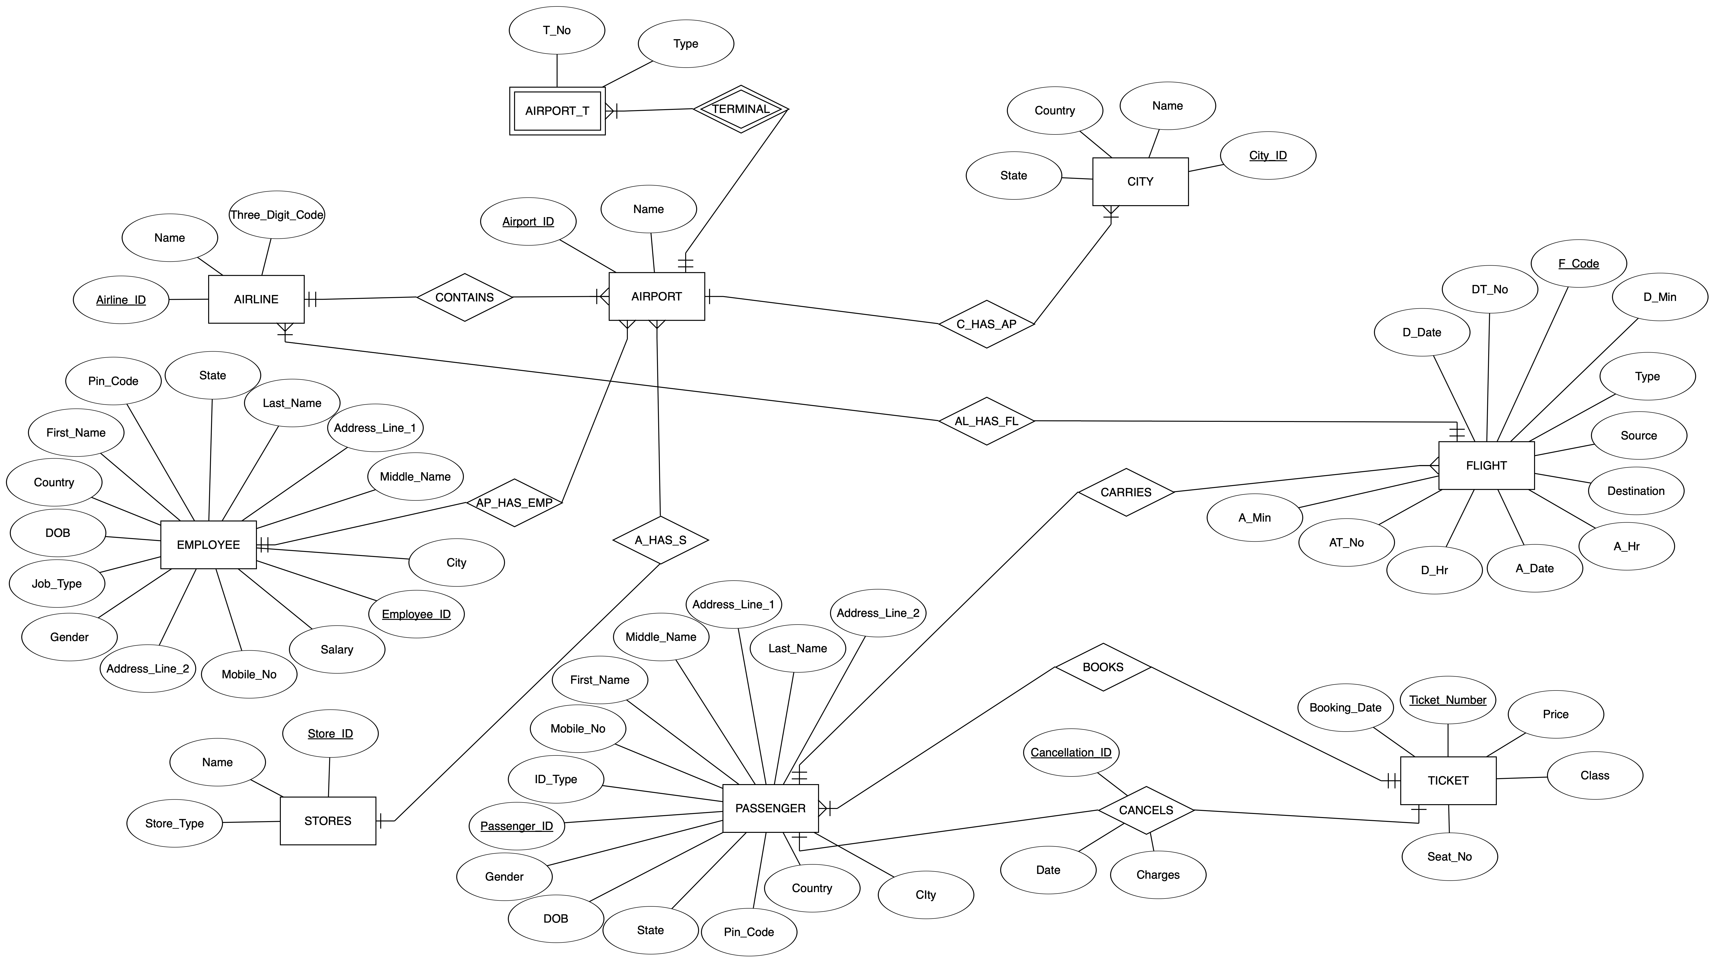

1. Relational Algebra Queries
   * + SELECT

(i) Select all the employees from "Maharashtra".

(ii) Select all the flights, departing on "03/03/2019".

(iii) Select all the Cancellations, whose Cancellation Charges are greater than "Rs.2000".

(iv) Select all the "Male" passengers.

* + - PROJECT

(i) Project the mobile number of all the employees.

(ii) Project the names of all the stores.

(iii) Project the Arrival Time of all the flights on "15/02/2019".

(iv) Project the DOB of all the passengers.



* + - CARTESIAN PRODUCT

(i) Project the "Employee_ID" and "Passenger_ID", for all the employees, whose last name and cities are same.

(ii) Project the "Employee_ID" and "Salary", of the employees, who have travelled at least once in any airplane.

(iii) Project the F_Code Pairs whose "Destination" and "D_Date" are same.

(iv) Project the Sources of the pair of flights, which depart from and arrive to the same terminals.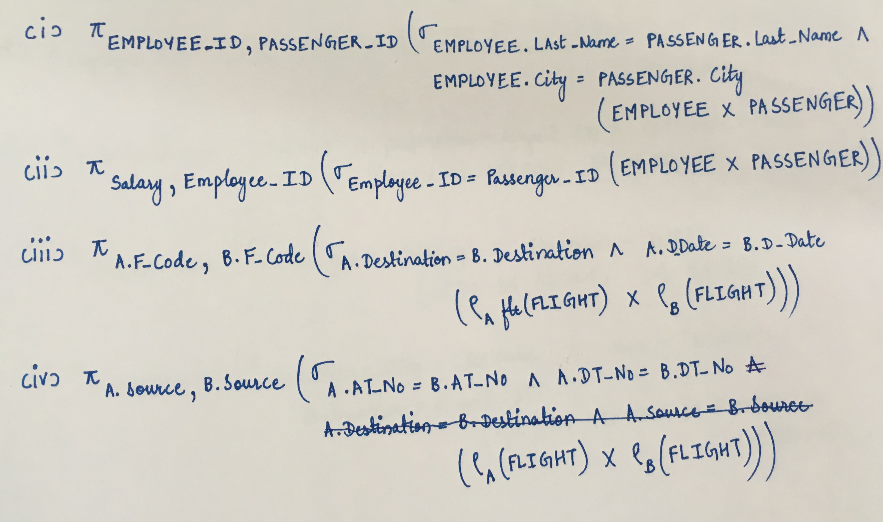

* + - UNION

(i) Project the "Employee_ID" of all the Employees, whose salary is more than "10000" or they are an "Engineer".

(ii) Project the "Passenger_ID" for all the Passengers, whose ID_Type is "Aadhar" or they are "Male".

(iii) Project the "F_Code" of all the Flights, whose type is "Domestic" or their Destination is "DEL1".

(iv) Project the "Passenger_ID" of all the Passengers, who either are leaving from their own City or are arriving to their own City.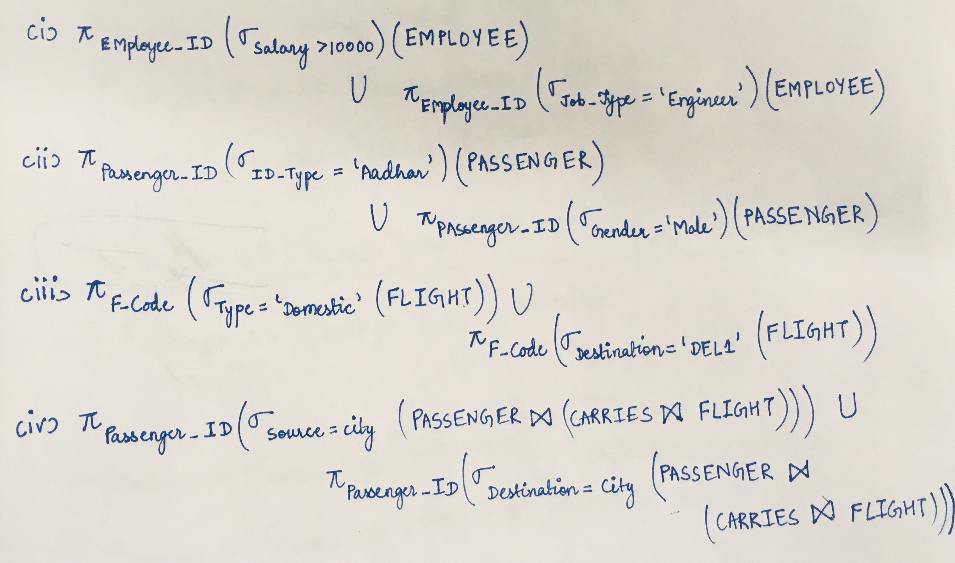

* + - SET DIFFERENCE

(i) Project the "Passenger_ID" of all the Indian Passengers, who haven’t submitted "Passport" as their ID.

(ii) Project the "Employee_ID" of all the Male Employees, who are not from "Chennai".

(iii) Project the "Passenger_ID" of all the Passengers travelling in flight, with "F_Code" as "A01".

(iv) Project the "Employee_ID" of all the Indian Employees, with salary less than "10000".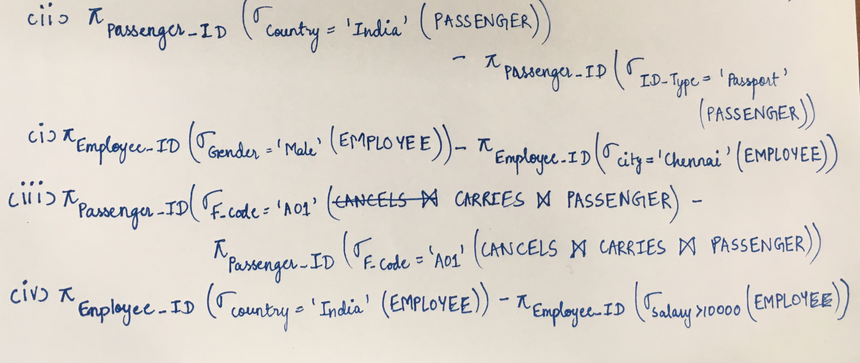

* + - NATURAL JOIN

(i) Project the "Employee_ID" of all the Employees, whose salary is greater than 10000 and are from "Mumbai".

(ii) Project the "F_Code" of all Flights, which will arrive in "Delhi" on "21/12/2018".

(iii) Project the "Name" of all the Stores of "Clothing" Type in any airport of "Delhi".

(iv) Project the "Passenger_ID", who are going back to their "HOME" City, on "31/12/2018".

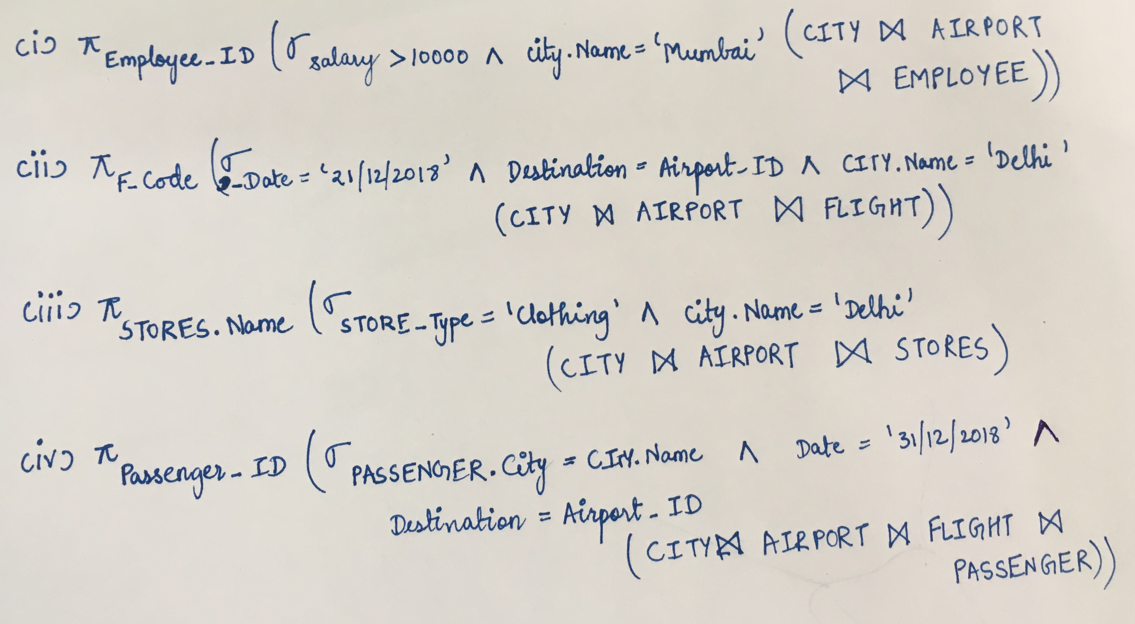

* + - ANY 2 of the ABOVE OPERATORS

(i) Project the "Airport_ID" of all Airports, which have more than "1" Terminal.

(ii) Project the "Passenger_ID" of all the Passengers from "India".

(iii) Project the "Salary" and "Employee_ID" of all the Male Employees.

(iv) Project the "Name" of all the "Clothing" Type Stores.

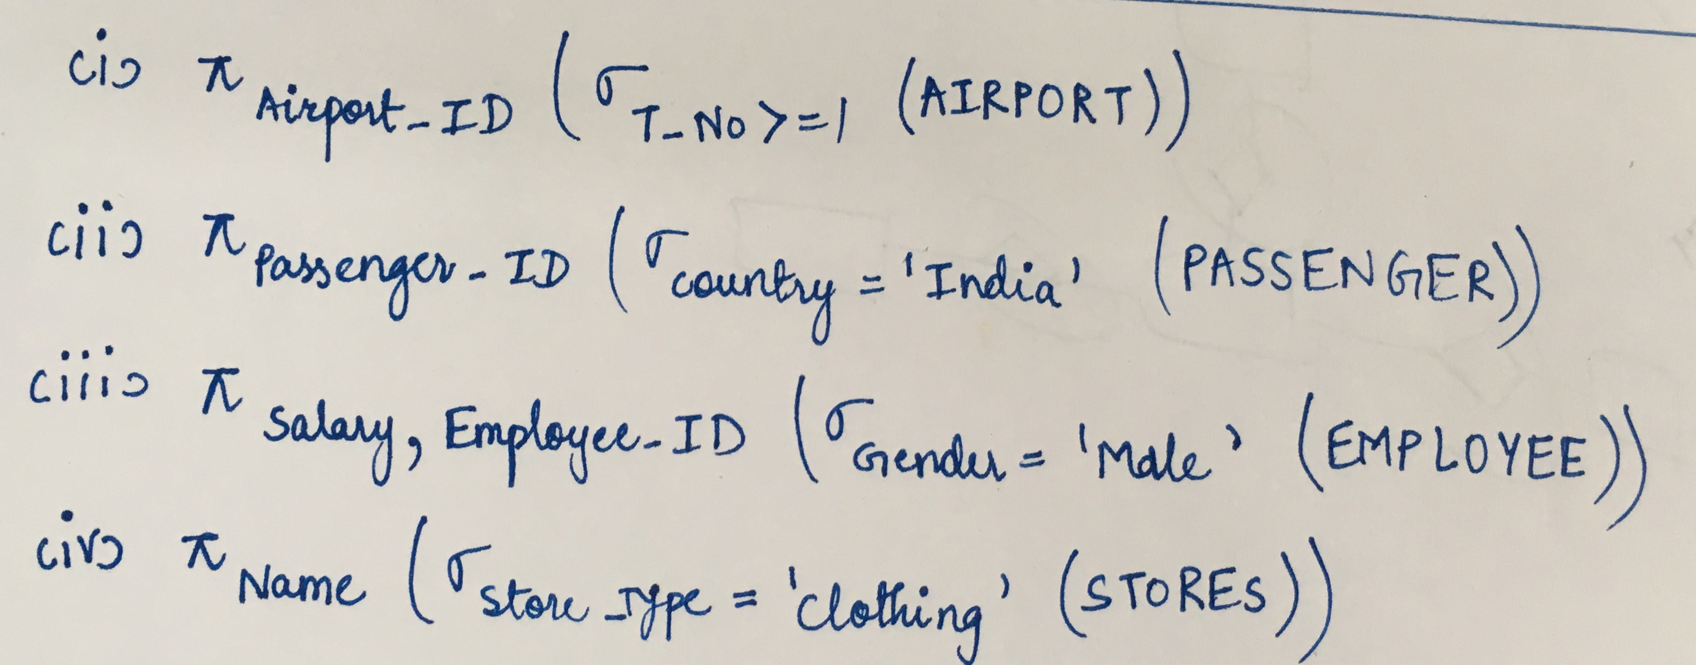

* + - ANY 3 of the ABOVE OPERATORS

(i) Project the "Passenger_ID" of all the Male Passengers, travelling in Flight "A01".

(ii) Project the "Employee_ID" of all Employees, at "B00" Airport.

(iii) Project the "Airport_ID" of all the Airports, of City "ABC", as its City_ID.

(iv) Project the "Airline_ID" of all the airlines at Airport "MUM1", as its "Airport_ID".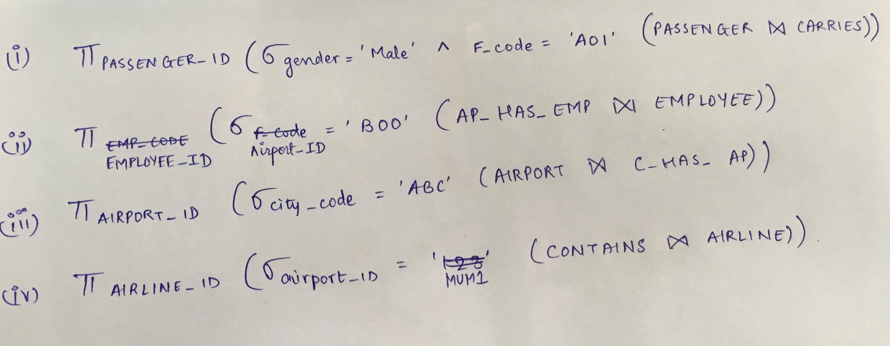

1. SQL
   * + CREATE Commands

CREATE TABLE CITY

(

Name VARCHAR(25) NOT NULL,

Country VARCHAR(25) NOT NULL,

State VARCHAR(25) NOT NULL,

City_ID CHAR(5) NOT NULL,

PRIMARY KEY (City_ID)

);

CREATE TABLE AIRPORT

(

Airport_ID CHAR(4) NOT NULL,

Name VARCHAR(70) NOT NULL,

PRIMARY KEY (Airport_ID)

);

CREATE TABLE EMPLOYEE

(

First_Name VARCHAR(25) NOT NULL,

Middle_Name VARCHAR(25) NOT NULL,

DOB DATE NOT NULL,

Employee_ID CHAR(5) NOT NULL,

Address_Line_1 VARCHAR(75) NOT NULL,

Mobile_No INT NOT NULL,

Gender ENUM('M', 'F', 'O') NOT NULL,

Job_Type VARCHAR(25) NOT NULL,

Salary FLOAT NOT NULL,

Last_Name VARCHAR(25) NOT NULL,

Address_Line_2 VARCHAR(75) NOT NULL,

City VARCHAR(25) NOT NULL,

State VARCHAR(25) NOT NULL,

Country VARCHAR(25) NOT NULL,

Pin_Code INT NOT NULL,

PRIMARY KEY (Employee_ID)

);

CREATE TABLE AIRLINE

(

Airline_ID CHAR(5) NOT NULL,

Name VARCHAR(30) NOT NULL,

Three_Digit_Code CHAR(3) NOT NULL,

PRIMARY KEY (Airline_ID)

);

CREATE TABLE FLIGHT

(

F_Code CHAR(4) NOT NULL,

Type VARCHAR(20) NOT NULL,

Source CHAR(4) NOT NULL,

Destination CHAR(4) NOT NULL,

A_Time CHAR(5) NOT NULL,

D_Time CHAR(5) NOT NULL,

A_Date DATE NOT NULL,

D_Date DATE NOT NULL,

DT_No INT NOT NULL,

AT_No INT NOT NULL,

PRIMARY KEY (F_Code)

);

CREATE TABLE PASSENGER

(

First_Name VARCHAR(25) NOT NULL,

Middle_Name VARCHAR(25) NOT NULL,

Last_Name VARCHAR(25) NOT NULL,

DOB DATE NOT NULL,

Gender ENUM('M', 'F', 'O') NOT NULL,

Passenger_ID CHAR(5) NOT NULL,

ID_Type VARCHAR(15) NOT NULL,

Mobile_No INT NOT NULL,

Address_Line_1 VARCHAR(75) NOT NULL,

Address_Line_2 VARCHAR(75) NOT NULL,

City VARCHAR(25) NOT NULL,

State VARCHAR(25) NOT NULL,

Country VARCHAR(25) NOT NULL,

Pin_Code INT NOT NULL,

PRIMARY KEY (Passenger_ID)

);

CREATE TABLE STORES

(

Name VARCHAR(30) NOT NULL,

Store_ID CHAR(5) NOT NULL,

Store_Type VARCHAR(30) NOT NULL,

PRIMARY KEY (Store_ID)

);

CREATE TABLE AIRPORT_T

(

T_No INT NOT NULL,

Type VARCHAR(20) NOT NULL,

Airport_ID CHAR(4) NOT NULL,

FOREIGN KEY (Airport_ID) REFERENCES AIRPORT(Airport_ID) on delete cascade

);

CREATE TABLE CONTAINS

(

Airline_ID CHAR(5) NOT NULL,

Airport_ID CHAR(4) NOT NULL,

FOREIGN KEY (Airline_ID) REFERENCES AIRLINE(Airline_ID) on delete cascade,

FOREIGN KEY (Airport_ID) REFERENCES AIRPORT(Airport_ID) on delete cascade

);

CREATE TABLE C_HAS_AP

(

City_ID CHAR(5) NOT NULL,

Airport_ID CHAR(4) NOT NULL,

FOREIGN KEY (City_ID) REFERENCES CITY(City_ID) on delete cascade,

FOREIGN KEY (Airport_ID) REFERENCES AIRPORT(Airport_ID) on delete cascade

);

CREATE TABLE A_HAS_S

(

Airport_ID CHAR(4) NOT NULL,

Store_ID CHAR(5) NOT NULL,

FOREIGN KEY (Airport_ID) REFERENCES AIRPORT(Airport_ID) on delete cascade,

FOREIGN KEY (Store_ID) REFERENCES STORES(Store_ID) on delete cascade

);

CREATE TABLE AL_HAS_FL

(

F_Code CHAR(4) NOT NULL,

Airline_ID CHAR(5) NOT NULL,

FOREIGN KEY (F_Code) REFERENCES FLIGHT(F_Code) on delete cascade,

FOREIGN KEY (Airline_ID) REFERENCES AIRLINE(Airline_ID) on delete cascade

);

CREATE TABLE CARRIES

(

Passenger_ID CHAR(5) NOT NULL,

F_Code CHAR(4) NOT NULL,

FOREIGN KEY (Passenger_ID) REFERENCES PASSENGER(Passenger_ID) on delete cascade,

FOREIGN KEY (F_Code) REFERENCES FLIGHT(F_Code) on delete cascade

);

CREATE TABLE CANCELS

(

Cancellation_ID CHAR(5) NOT NULL,

Date DATE NOT NULL,

Charges FLOAT NOT NULL,

Passenger_ID CHAR(5) NOT NULL,

Ticket_Number CHAR(6) NOT NULL,

PRIMARY KEY (Cancellation_ID),

FOREIGN KEY (Passenger_ID) REFERENCES PASSENGER(Passenger_ID) on delete cascade,

FOREIGN KEY (Ticket_Number) REFERENCES TICKET(Ticket_Number) on delete cascade

);

CREATE TABLE AP_HAS_EMP

(

Employee_ID CHAR(5) NOT NULL,

Airport_ID CHAR(4) NOT NULL,

FOREIGN KEY (Employee_ID) REFERENCES EMPLOYEE(Employee_ID) on delete cascade,

FOREIGN KEY (Airport_ID) REFERENCES AIRPORT(Airport_ID) on delete cascade

);

CREATE TABLE TICKET

(

Ticket_Number CHAR(6) NOT NULL,

Price FLOAT NOT NULL,

Class VARCHAR(15) NOT NULL,

Seat_No VARCHAR(4) NOT NULL,

Booking_Date DATE NOT NULL,

PRIMARY KEY (Ticket_Number)

);

CREATE TABLE BOOKS

(

Passenger_ID CHAR(5) NOT NULL,

Ticket_Number CHAR(6) NOT NULL,

FOREIGN KEY (Passenger_ID) REFERENCES PASSENGER(Passenger_ID) on delete cascade,

FOREIGN KEY (Ticket_Number) REFERENCES TICKET(Ticket_Number) on delete cascade

);